006BC2744 - Day 9 (28 July 2026)

Task 1: Can you create a Maven based spring project using ide.. To print a welcome..

Task 2: Now create a POJO class for student so that can be managed as a spring bean

package org.bank.entities;

public class Student {

private int id;

private String name;

private String email;

private String password;

private String address;

public Student(int id, String name, String email, String password, String address) {
this.id = id;
this.name = name;
this.email = email;
this.password = password;
this.address = address;
}

public int getId() {
return id;
}

public void setId(int id) {
this.id = id;
}

@Override
public String toString() {
return "Student{" +
"id=" + id +
", name='" + name + '\'' +
", email='" + email + '\'' +
", password='" + password + '\'' +
", address='" + address + '\'' +
'}';
}

public String getName() {
return name;
}

public void setName(String name) {
this.name = name;
}

public String getEmail() {
return email;
}

public void setEmail(String email) {
this.email = email;
}

public String getPassword() {
return password;
}

public void setPassword(String password) {
this.password = password;
}

public String getAddress() {
return address;
}

public void setAddress(String address) {
this.address = address;
}
}

Task 3: Configure the above Student bean in the bean-factory-demo.xml file.
That means you need to configure the Student bean in the XML file so the BeanFactory knows how to create it.
And create a main class and run it..

<beans xmlns="http://www.springframework.org/schema/beans"
xmlns:xsi="http://www.w3.org/2001/XMLSchema-instance"
xmlns:context="http://www.springframework.org/schema/context"
xsi:schemaLocation="
http://www.springframework.org/schema/beans
https://www.springframework.org/schema/beans/spring-beans.xsd
http://www.springframework.org/schema/context
https://www.springframework.org/schema/context/spring-context.xsd">

<context:component-scan base-package="org.bank"/>

<bean id="student" class="org.bank.entities.Student">
<constructor-arg name="id" value="101"/>
<constructor-arg name="name" value="Bharggav"/>
<constructor-arg name="email" value="abcxyz"/>
<constructor-arg name="password" value="12345"/>
<constructor-arg name="address" value="Tirumanhalli"/>
</bean>

</beans>

Task 4: Can you explain application context with the syntax..

ApplicationContext is the most commonly used Spring IoC container. It reads the Spring configuration (XML, annotations, or Java config), creates and manages beans, injects their dependencies, and provides additional features like event handling and resource loading.

Code:
ApplicationContext context =
new ClassPathXmlApplicationContext("applicationContext.xml");

Student student = context.getBean("student", Student.class);

Here, ApplicationContext loads applicationContext.xml, creates the student bean, and returns it when getBean() is called.
Task 5: Why use application context .. plz list some uses?

* It creates and manages Spring beans automatically, so you don't need to create objects using `new`.
* It injects dependencies between objects using Dependency Injection (DI).
* It supports advanced features like event handling, internationalization (i18n), resource loading, and bean lifecycle management.
* It is the recommended IoC container in Spring and is more powerful than `BeanFactory`.

Task 6: What are features of Spring Framework .. list them with 1 or 2 lines explanation?

Features of Spring Framework

1. Dependency Injection (DI) – Automatically injects dependencies between objects, reducing tight coupling.

2. Inversion of Control (IoC) – Spring manages the creation and lifecycle of objects (beans).

3. Aspect-Oriented Programming (AOP) – Separates common functionalities like logging, security, and transactions from business logic.

4. Lightweight Framework – Requires minimal resources and is easy to develop and deploy applications with.

5. Modular Architecture – Spring consists of independent modules, so you can use only the ones you need.

6. Transaction Management – Provides simple and reliable support for database transactions.

7. Spring MVC – Offers a framework for building web applications using the Model-View-Controller pattern.

8. Data Access Support – Simplifies database operations with JDBC, JPA, Hibernate, and other persistence frameworks.

9. Integration Support – Easily integrates with technologies like Hibernate, JPA, JMS, REST APIs, and more.

10. Testing Support – Provides built-in support for unit and integration testing with frameworks like JUnit and Mockito.
Task 7: Why do you think we use spring framework.. Advantages list them down?

Advantages of Spring Framework

1. Reduces Boilerplate Code – Spring handles object creation and dependency management automatically.

2. Loose Coupling – Uses Dependency Injection (DI), making applications easier to maintain and modify.

3. Easy Integration – Works seamlessly with Hibernate, JPA, JDBC, REST APIs, and other Java technologies.

4. Simplifies Database Operations – Provides built-in transaction management and data access support.

5. Supports Rapid Development – Offers reusable modules and simplifies enterprise application development.

6. Easy Testing – Provides excellent support for unit and integration testing using JUnit and Mockito.

Task 8: What do you understand about the IOC? Explain with a diagram..

IoC (Inversion of Control) is a core principle of Spring where the Spring container creates and manages objects (beans) instead of the programmer creating them using new. This makes applications loosely coupled, easier to maintain, and easier to test.

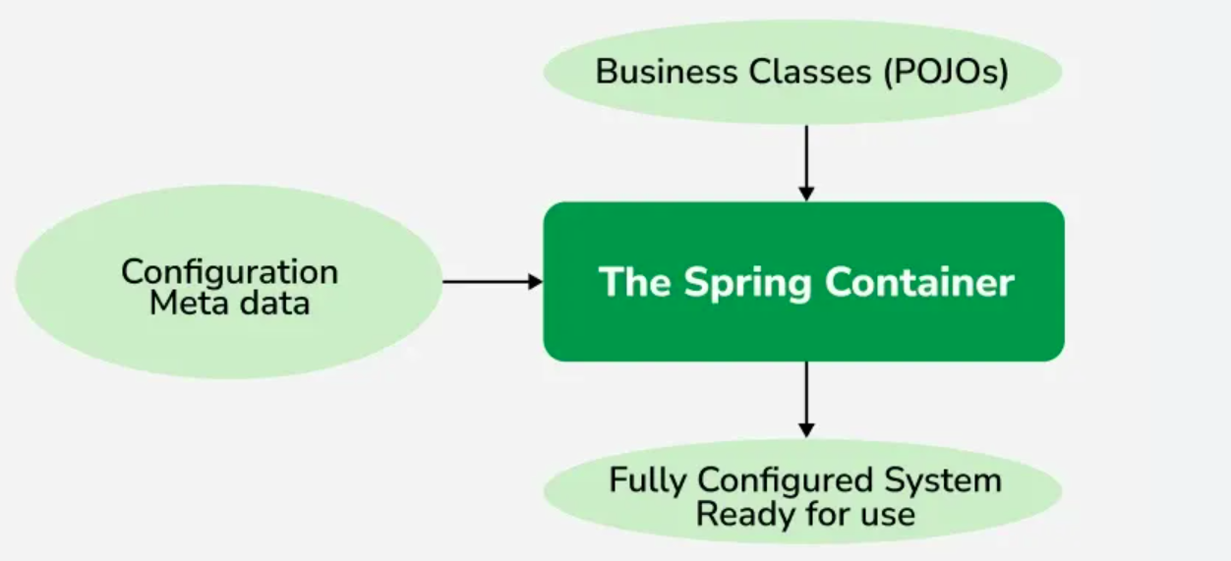

Key idea: Instead of your code creating objects, the Spring IoC container creates them and injects the required dependencies automatically.

Task 9: How many types of IOC do you have in spring? What are they with explanation

Spring has two main types of IoC containers: BeanFactory and ApplicationContex

BeanFactory:The BeanFactory is the most basic and lightweight IoC container in Spring. It provides core dependency injection functionality and uses lazy initialization, meaning it creates beans only when you request them. It is best suited for small or memory-constrained.

ApplicationContext:The ApplicationContext is an advanced, feature-rich extension of the BeanFactory. It eagerly loads singleton beans at startup and adds enterprise features like event handling, internationalization, and AOP integration. It is the standard container used in modern Spring applications.

Task 10: What is DI in spring?

Dependency Injection (DI) is a core feature of Spring in which the Spring container provides the required objects (dependencies) to a class instead of the class creating them using `new`. This promotes loose coupling, making the application easier to maintain, test, and extend.

Task 11: How many types of DI do we have? Explain

In Spring, there are 2 main types of Dependency Injection (DI).

1. Constructor Injection – The dependency is passed through the class constructor. It is best when the dependency is required for object creation.
2. Setter Injection – The dependency is passed through a setter method after the object is created. It is useful when the dependency is optional or may change later.

Both types help Spring provide objects automatically and keep the code loosely coupled.

Task 12: What is Spring Application Configuration?

Spring Application Configuration is the process of telling the Spring container which beans to create, how to configure them, and how they depend on each other. It can be done using XML configuration, annotations (such as `@Component` and `@Service`), or Java-based configuration (`@Configuration`).

Task 13: What are the different ways to configure spring applications?

There are 3 main ways to configure a Spring application:

1. XML Configuration – Define beans and their dependencies in an XML file (e.g., `applicationContext.xml`).
2. Annotation-Based Configuration – Use annotations like `@Component`, `@Service`, `@Repository`, and `@Autowired` to configure beans.
3. Java-Based Configuration – Use `@Configuration` and `@Bean` annotations in Java classes instead of XML.

Among these, annotation-based and Java-based configuration are the most commonly used in modern Spring applications.

Task 14: Why do we need spring application configuration?

We need Spring Application Configuration to tell the Spring container which beans to create, how to configure them, and how they should be connected (dependencies). It centralizes application setup, making the code easier to maintain, manage, and modify without changing the business logic.

Task 15: What are the different ways to configure spring applications?

There are three main ways to configure a Spring application:

1. XML Configuration – Configure beans and dependencies in an XML file (e.g., `applicationContext.xml`).
2. Annotation-Based Configuration – Use annotations like `@Component`, `@Service`, `@Repository`, and `@Autowired`.
3. Java-Based Configuration – Use Java classes with `@Configuration` and `@Bean` annotations instead of XML.

Task 16: What is bean scope .. give different scopes with description

Bean Scope defines the lifecycle and visibility of a Spring bean, i.e., how many instances of a bean Spring creates and how long they live.

Different Bean Scopes

1. Singleton (Default) – Only one instance of the bean is created and shared throughout the Spring container.
2. Prototype – A new instance is created every time the bean is requested.
3. Request – One bean instance is created per HTTP request (Web applications only).
4. Session – One bean instance is created per HTTP session (Web applications only).
5. Application – One bean instance is shared for the entire web application.
6. WebSocket – One bean instance is created per WebSocket session.

Task 17: What is autowiring in spring?

Autowiring is a feature of Spring that automatically injects the required dependency (bean) into another bean, so you don't need to configure the dependency manually. It is commonly done using the `@Autowired` annotation, which helps reduce configuration and keeps the code loosely coupled.

Task 18: What are diff ways of autowiring?

There are two common ways to perform autowiring in Spring:

1. Constructor Autowiring – Dependencies are injected through the class constructor. This is the recommended approach because it makes required dependencies explicit and supports immutable objects.
2. Setter (or Field) Autowiring – Dependencies are injected through setter methods or directly into fields using `@Autowired`. Setter injection is useful for optional dependencies, while field injection is generally not recommended for production code.

Task 19: What is the difference between a normal java object and Spring bean?

A normal Java object is created manually using the `new` keyword, and its lifecycle and dependencies are managed by the programmer. A Spring bean is created, configured, and managed by the Spring IoC container, which also injects its dependencies automatically using Dependency Injection (DI).

Task 20: What is diff between @ component and @ bean

`@Component` is used in a class to let Spring automatically detect and create it as a bean during component scanning. `@Bean` is used on a method inside a `@Configuration` class to explicitly create and configure a bean that Spring will manage.

In short: `@Component` = automatic bean creation, while `@Bean` = manual bean creation and configuration.

Task 21: A different way to create an application using
https://start.spring.io/ try it .. and let me know what is it?

Task 22: Using Spring initialiser create an employee class , appconfig file, and main class and see how it works

Task 23: We have spring annotations:
Like

@bean Creates and registers an object as a Spring bean, usually inside a @Configuration class.

@controller Marks a class as a Spring MVC controller that handles web requests.

@value Injects values from properties files, environment variables, or expressions into fields.

@conponentScan Tells Spring which packages to scan for classes annotated with @Component, @Service, etc.

@configuration Marks a class as a configuration class that defines Spring beans and application setup.

@service Marks a class as a service/business-logic component managed by Spring.

@repository Marks a class as a data-access/DAO component and provides database exception translation.

@Qualifier Specifies which bean should be injected when multiple beans of the same type exist.

@required Indicates that a required property must be set during bean configuration; deprecated since Spring 5.1.

@component Marks a class as a Spring-managed bean that can be automatically detected through component scanning.

@autowired Automatically injects a required dependency into a constructor, field, or setter.

@scope Defines the lifecycle/scope of a Spring bean, such as singleton or prototype.

Task 24: What are the features of springboot?

Features of Spring Boot

* Auto-Configuration – Automatically configures your application based on the dependencies you include.
* Starter Dependencies – Provides ready-made dependencies like `spring-boot-starter-web` to simplify setup.
* Embedded Server – Includes servers like Tomcat, so you can run applications without deploying a WAR file.
* Production Ready – Provides features such as health checks, monitoring, and metrics through Spring Boot Actuator.
* Less Configuration – Reduces boilerplate XML and configuration, allowing faster application development.

Task 25: What are the advantages of Spring boot?

- Faster Development – Auto-configuration and starter dependencies reduce setup and boilerplate code.
- Easy Deployment – Embedded servers like Tomcat allow applications to run directly as standalone applications.
- Less Configuration – Requires minimal XML/configuration compared to traditional Spring.
- Production Ready – Provides built-in support for monitoring, health checks, and metrics.
- Easy Integration – Works easily with databases, REST APIs, security, JPA, and other Spring modules.

Task 26: What are the key components of Spring boot?

- Spring Boot Starters – Pre-configured dependencies that simplify adding features like Web, JPA, and Security.
- Auto-Configuration – Automatically configures the application based on the dependencies available.
- Embedded Server – Provides servers like Tomcat, Jetty, or Undertow to run applications directly.
- Spring Boot Actuator – Provides production features such as health checks, monitoring, and metrics.
- Spring Boot CLI – A command-line tool that helps develop and run Spring applications quickly.

Task 27: Why spring boot over spring?

Spring Boot is preferred over traditional Spring because it reduces configuration and boilerplate code using auto-configuration and starter dependencies. It also provides embedded servers and production-ready features, making application development and deployment faster and easier.

Task 28: Can you explain the internal working of spring boot?

Spring Boot starts with SpringApplication.run(), which creates the Spring Application Context and scans/configures the required components.
It uses auto-configuration and starter dependencies to configure beans and services automatically, then starts the embedded server (such as Tomcat) to run the application.

Task 29: List out the starter dependencies for spring boot

- spring-boot-starter-web – For building web applications and REST APIs.
- spring-boot-starter-data-jpa – For database access using JPA/Hibernate.
- spring-boot-starter-test – For unit and integration testing.
- spring-boot-starter-security – For authentication and authorization.
- spring-boot-starter-validation – For validating request data.
- spring-boot-starter-actuator – For monitoring and health checks.
- spring-boot-starter-jdbc – For database connectivity using JDBC.
- spring-boot-starter-thymeleaf – For building server-side web pages.

Task 31: What is the syntax to change the port of the embedded Tomcat server in Spring Boot?

server.port=8081

